**ER DIAGRAM FOR CAR CONNECT**

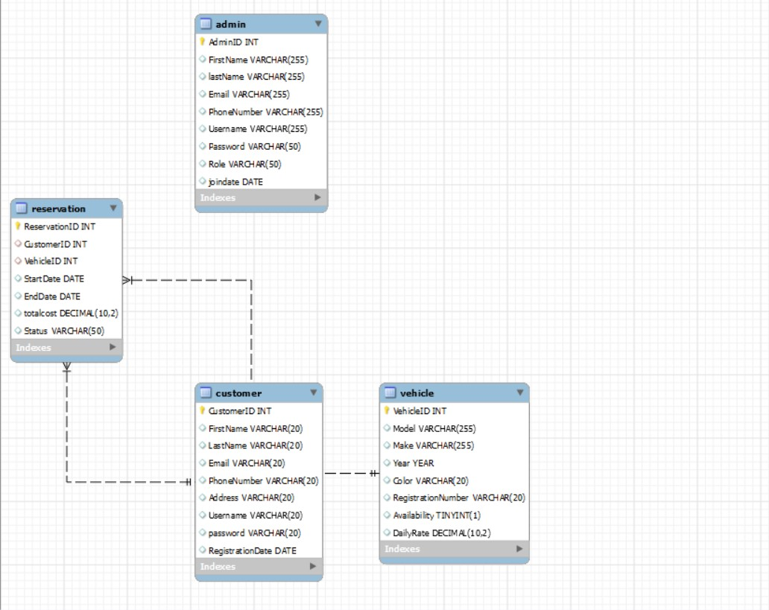

**K.JASMITHA**

**J219**